**ESHAPE (****Morphology Analysis tools)**

**User Guide**

1. Introduction 2

2. Installing and compiling 2

3. Functions 3

3.1 Contour extraction page 3

3.2 Ellipse Fourier Analysis page 12

# Introduction

The elliptic Fourier analysis (EFA) can extract arbitrary two-dimensional curves to a series of elliptic Fourier descriptors (EFDs), which was originally proposed by Kuhl and Giardina in 1982 for object recognition of a segment in an image. As a powerful mathematical tool, EFA can provide quantitative criteria for shape analysis, classification, reconstruction, and modeling, which has been widely used in plant science, marine biology, evolutionary biology and anthropology. The procedure of GM using EFA includes contour extraction, EFDs calculation and EFD normalization. Aside from the low efficiency in outline extraction and low quantity in datasets, EFD normalization has long been a matter of trouble (Haines and Crampton 2000, Bonhomme et al., 2014, Wishkerman et al., 2018). None of existing normalization method can give homologous results when dealing with planar translation, scaling, rotation, symmetry, reverse, and analogous basic transformations simultaneously. Therefore, it is of great significance to improve the computational efficiency of EFA for true EFD normalization and develop a user-friendly software for organ annotation and geometric feature extraction using digital specimens.

In this study, we develop a user-friendly software ESHAPE for public service, integrating better contour extraction, efficient EFDs calculation, and true EFD normalization under all basic contour transformations.

# Installing and compiling

This software is developed using MATLAB and requires version 2016a or later for compilation and execution.

ESHAPE can be downloaded from the following website: https://github.com/jiajie789/ESHAPE. After downloading, extract all the files from 'ESHAPE.zip' into a folder named 'ESHAPE'. Locate the 'ESHAPE.m' file in this folder and run it using MATLAB. This will take you to the main program page. A successful installation will be indicated as shown in Fig. 1

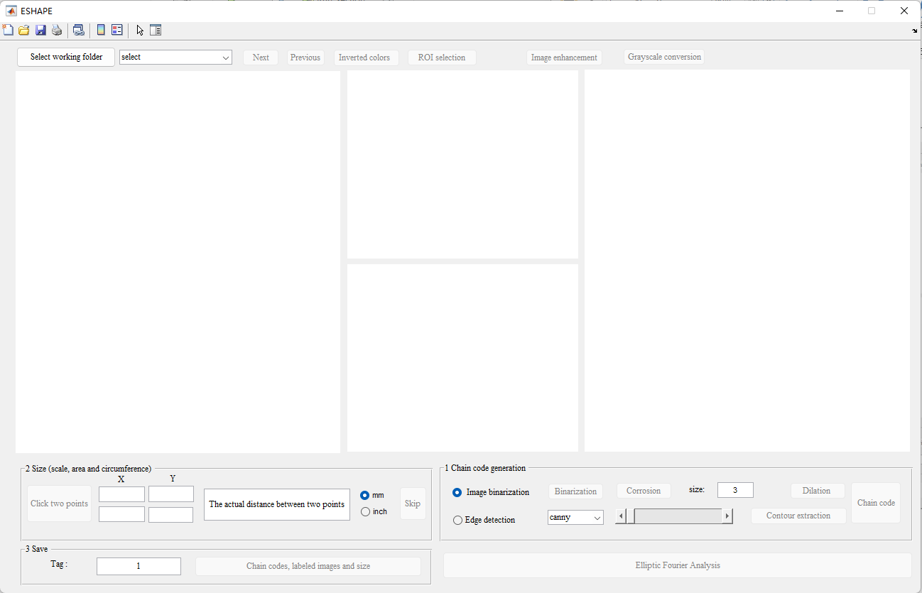

Figure

# Functions

This software encompasses two parts: contour extraction and elliptic Fourier analysis.

## Contour extraction page

The process of contour extraction includes four steps: manual target selection, automatic segmentation, automatic contour outlining with manual correction and automatic chain code generation. Many functions focus on meeting the challenges of contour extraction generated in the preservation and digitization process of specimens, such as incomplete edges by white strips, low image contrast, noises by fragile, overlapping and damaged organs.

**Step 1: Load the images.**

Click the 'Select working folder' button and choose the folder where your image files are located. All file names with extensions '.jpg', '.png', '.tif', and '.bmp' will be displayed in the popup menu. Click on the name of the image file you want to analyze to load it into the program (Fig. 2). You can use the 'Next' and 'Previous' buttons to navigate between the loaded images.

The test images are in the 'ESHAPE' folder that you downloaded.

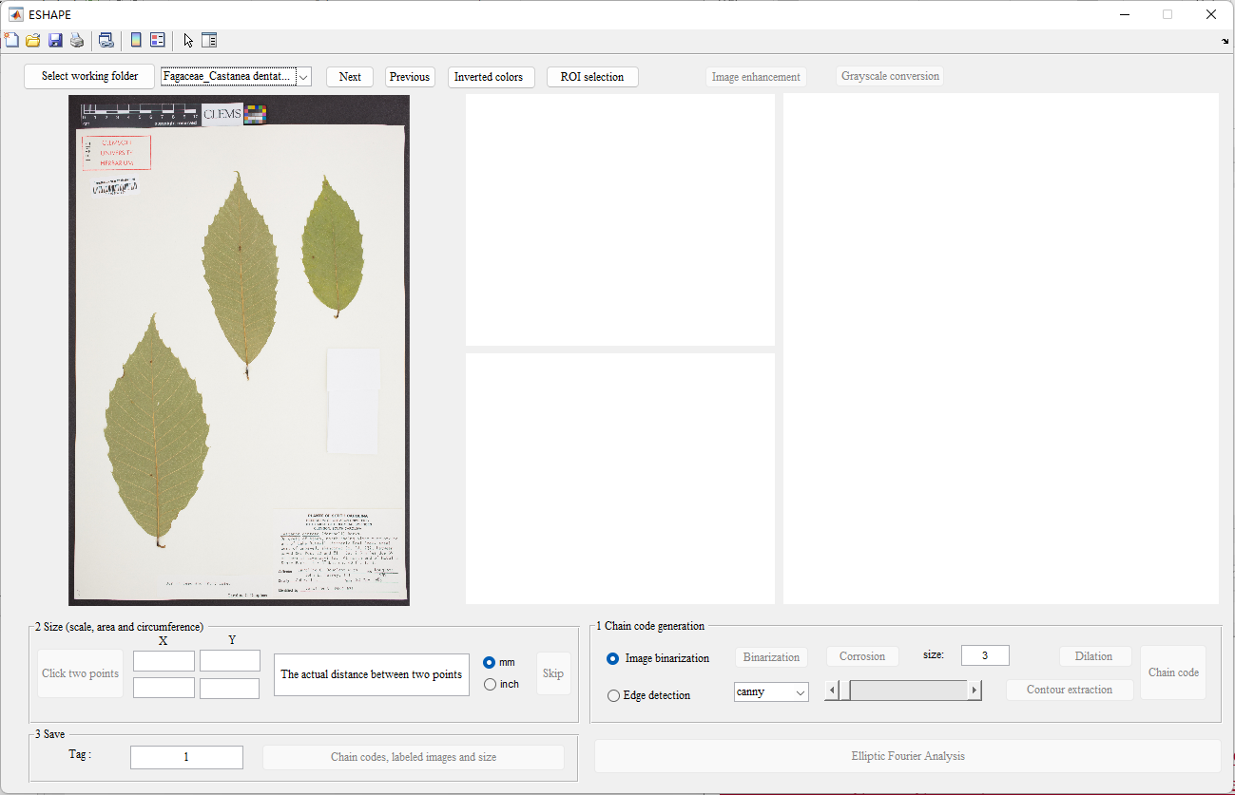

Figure

**Step 2: Inverted colors**

If the foreground objects have higher grayscale values and noticeable contrast with the surrounding background, there is no need to use the 'Inverted Colors' function. If they do not, then you should use it.

An example of an image with a black background is shown in Fig. 3.

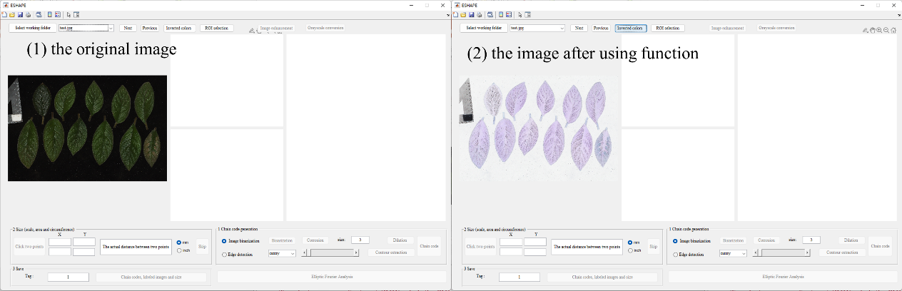

Figure

**Step 3: ROI Selection**

Users can zoom in and out by utilizing the mouse scroll wheel and move left and right by pressing and holding the left button to quickly locate the object (Fig. 4).

To select a region of interest (ROI), click the 'ROI Selection' button. Users can draw a polygon around the selected leaf by left-clicking to drop connected points. Right-clicking will connect the start and end points (Fig. 5). Simultaneously, the upper middle picture window will display the result of grayscale conversion of the selected object.

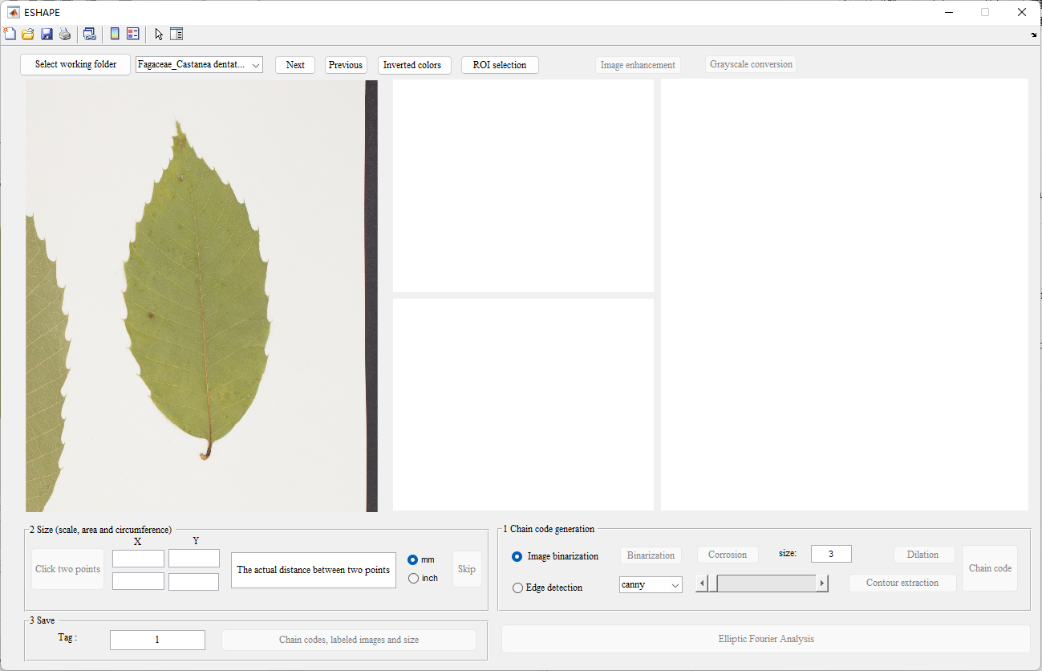

Figure 4

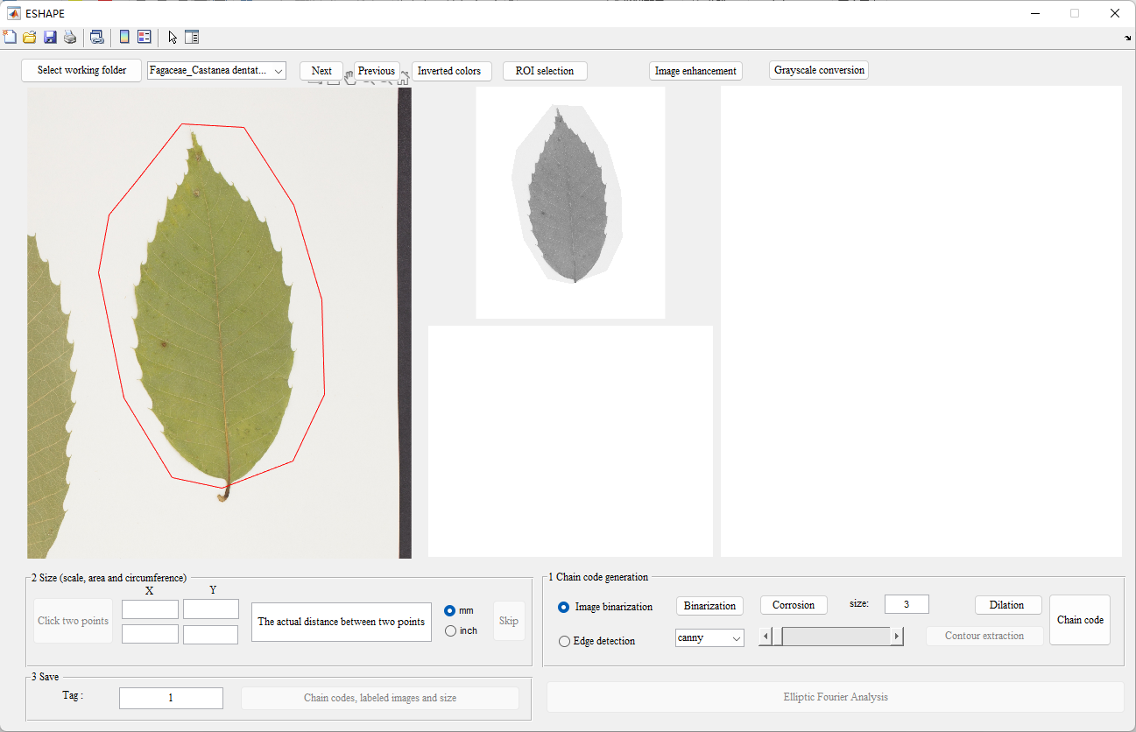

Figure

**Step 4: Image enhancement and grayscale conversion**

If the foreground objects have noticeable contrast with the surrounding background, this step can be skipped. If they don’t, then it should be used, as illustrated in Fig. 6.

Note: Clicking the 'Image Enhancement' button multiple times will superimpose the enhanced effect. If you find that the enhancement effect is not satisfactory, you can click the 'Grayscale Conversion' button to revert to the original grayscale image without the enhancement operation.

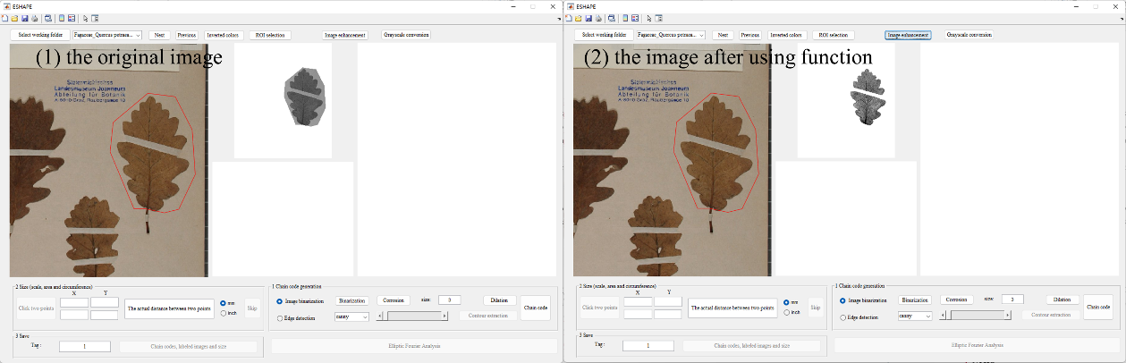

Figure 6

**Step 5: Chain code generation**

We provide two methods for obtaining the object contour. Users can choose between 'Image Binarization' or 'Edge Detection' by clicking the respective radio button (Fig. 7). 'Image Binarization' is the default method for contour extraction.

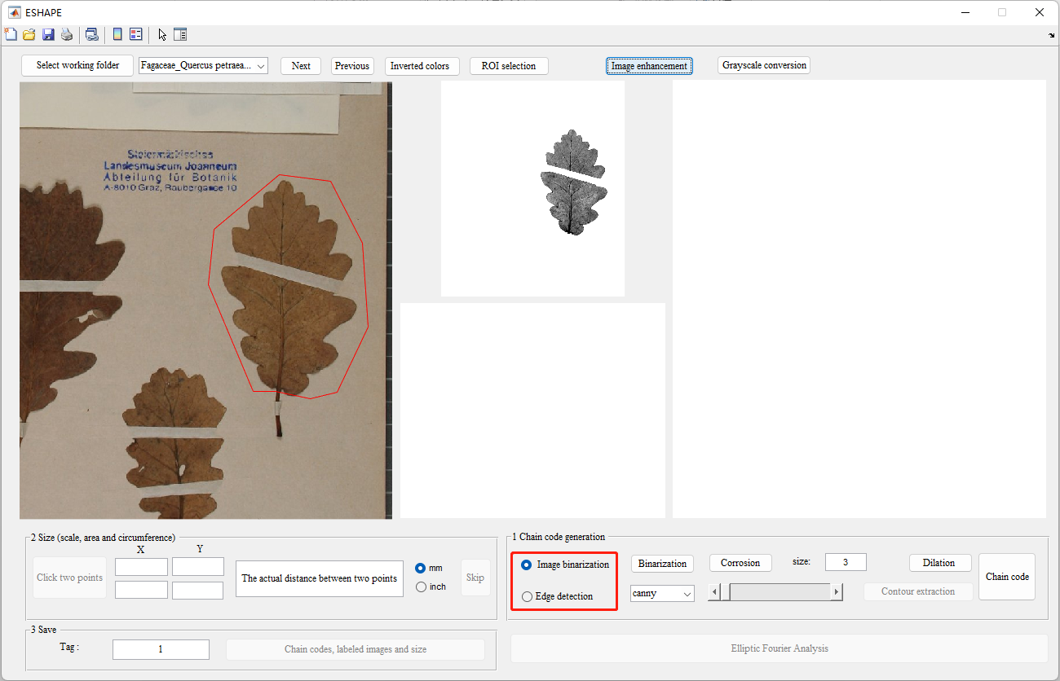

Figure

**Method 1: Contour extraction based on “Image binarization”**

Click the 'Binarization' button to convert the processed grayscale image into a binary image. The result will be displayed in the window below the middle section and in the enlarged view window on the right (Fig. 8).

If noise needs to be reduced in your images, click the 'Erosion' button. The value in the box next to this button determines the size of the erosion operation, which can be adjusted based on the desired results.

To fill small gaps or holes in the target region that hinder the formation of closed curves, click the 'Dilation' button to obtain the correct boundary (Fig. 9).

If there is a breakage in the middle of your target object, you can use the 'Editing' function in the right window. Users can zoom in on the image using the mouse scroll wheel to locate the extent of the breakage. Scrolling the mouse wheel forward zooms in, while scrolling it backward zooms out. To pan the image, long-press the right mouse button and drag. To draw white lines and connect, long-press the left mouse button and drag (Fig. 10). Left-clicking on a pixel using the mouse will change the value of the binary image, toggling between black and white.

Notes:

(1) The more times you perform dilation, the greater the distortion of the object. Therefore, the number of times used should be appropriate.

(2) Before editing the image, it's important to zoom in until one pixel is clearly visible (Fig. 10); otherwise, there may be positional deviations.

(3) Whether to use erosion, dilation, and editing functions depends on the specific circumstances.

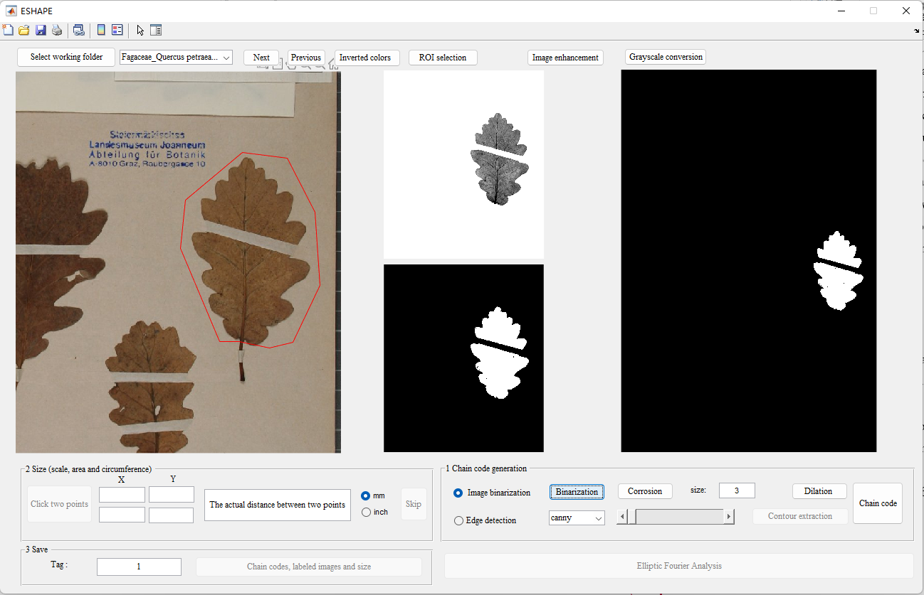

Figure

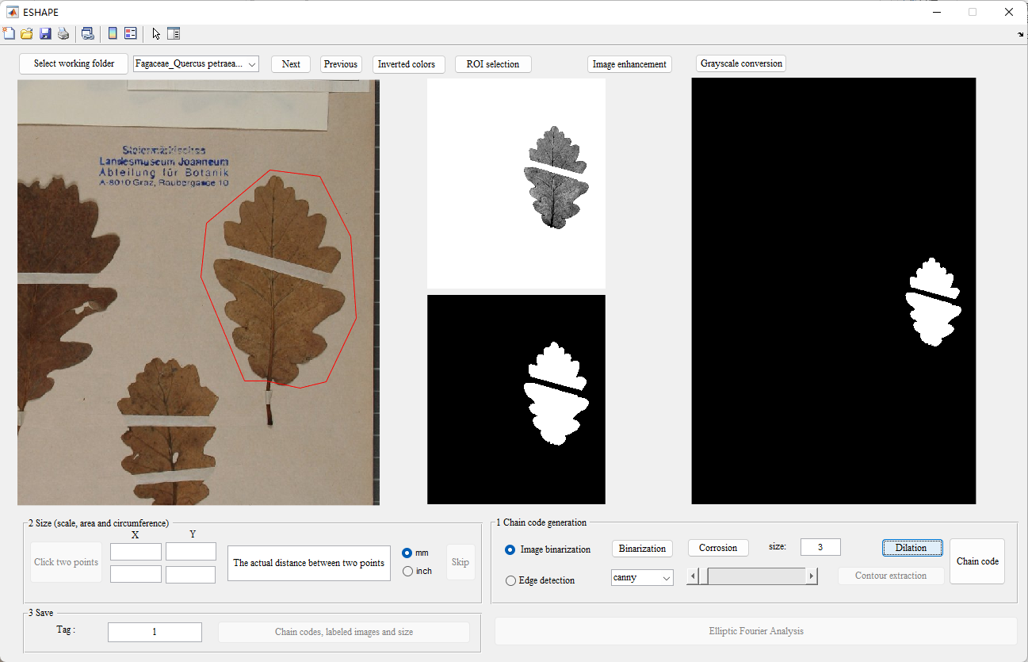

Figure

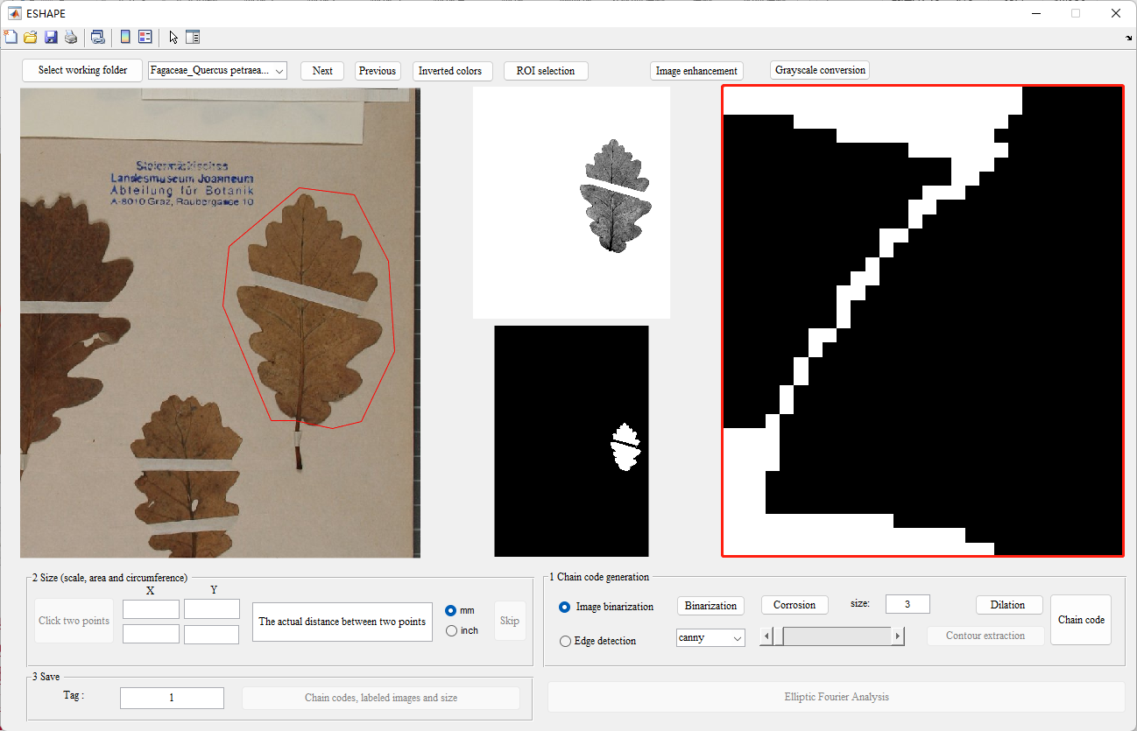

Figure

Afterward, click the 'Chain Code' button, and a message box will appear indicating whether the chain code extraction was successful. The correctness and closure of the chain code can be determined based on its length and the presence of a red line in the middle right window. If the chain code is not closed, the location of the break will be enlarged and displayed in the editing window. Users can make further edits and then click the 'Chain Code' button again until the result is correct.

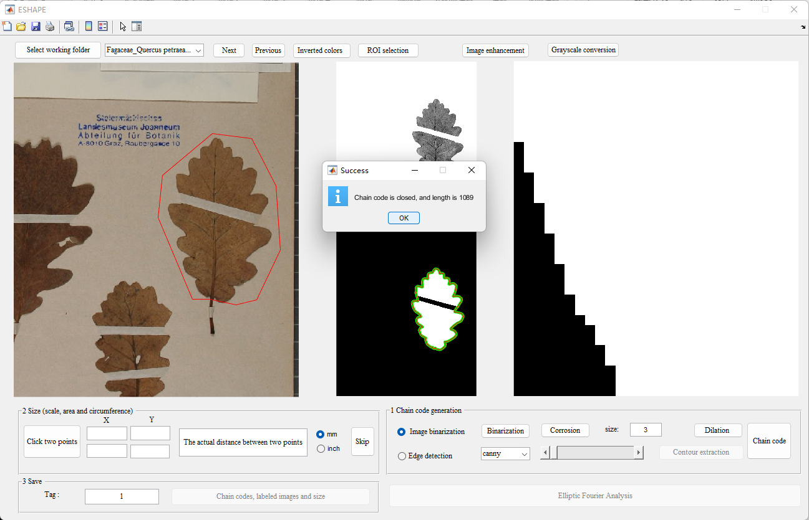

Figure

**Method 2: Contour extraction based on “Edge detection”**

Various methods, including Canny, Sobel, Prewitt, and Roberts operators, as well as the log and zero-cross detectors, are listed in the popup menu (Fig. 12). Click the name of the method you want to use and adjust the threshold using the slider. A lower threshold detects more details, while a higher threshold detects fewer details. The appropriate threshold is achieved when clear edge contours are visible (Fig. 13).

In the editing window, you can connect disjointed contours and correct any contour errors (Fig. 14). Click the 'Chain Code' button to obtain the correct edge contour (green line) and chain code (red line) as shown in Fig. 15.

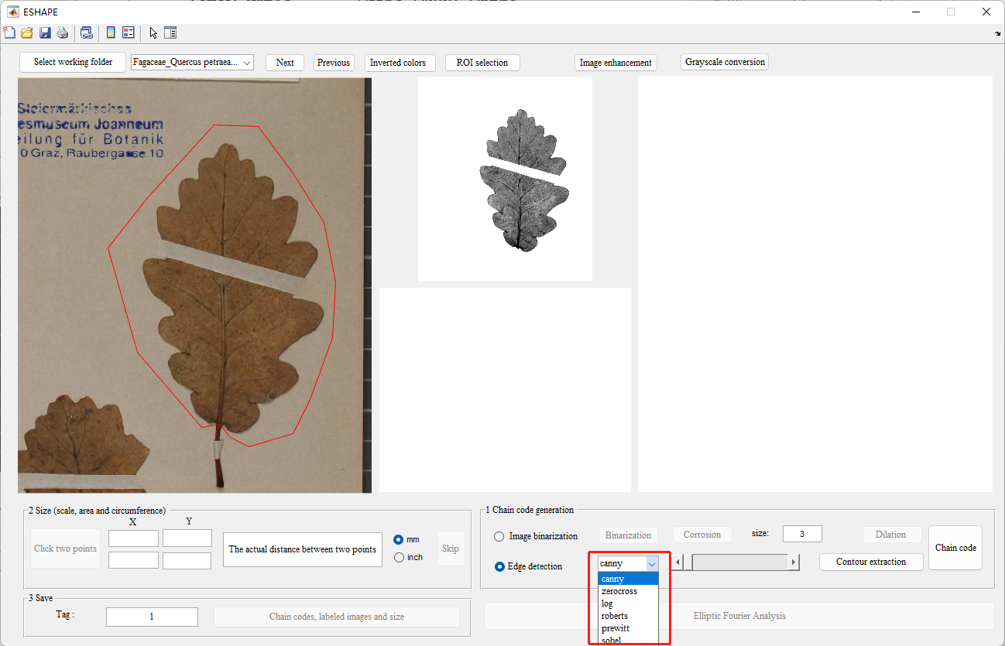

Figure 12

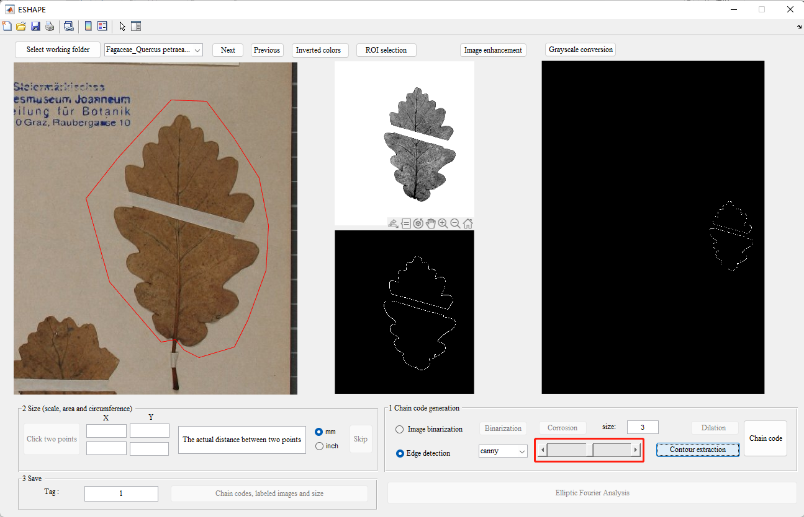

Figure

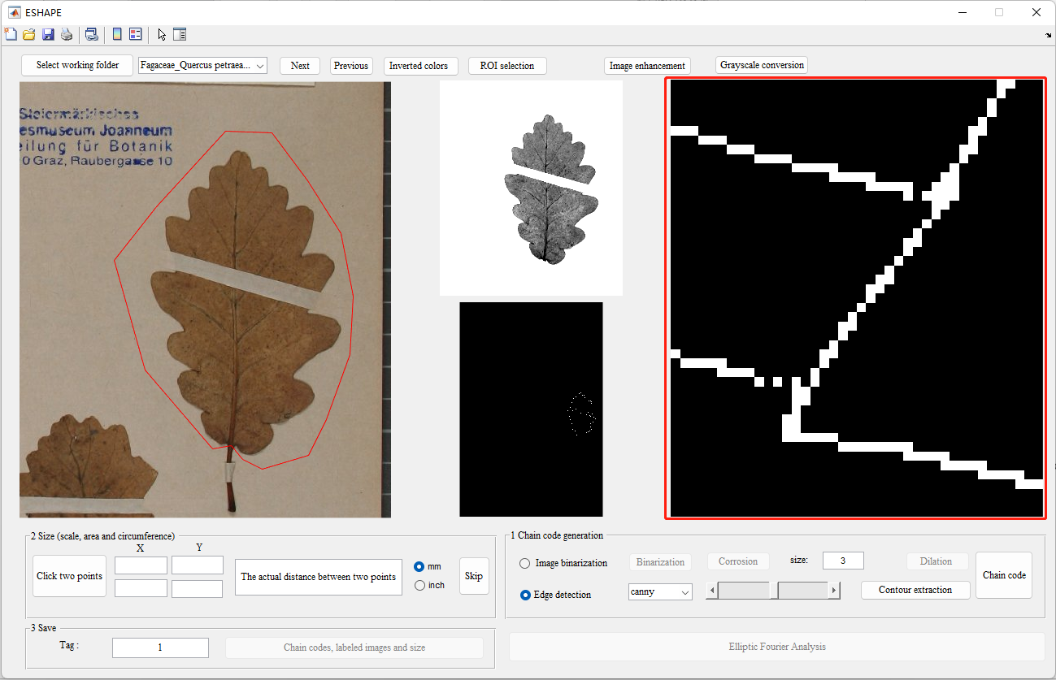

Figure

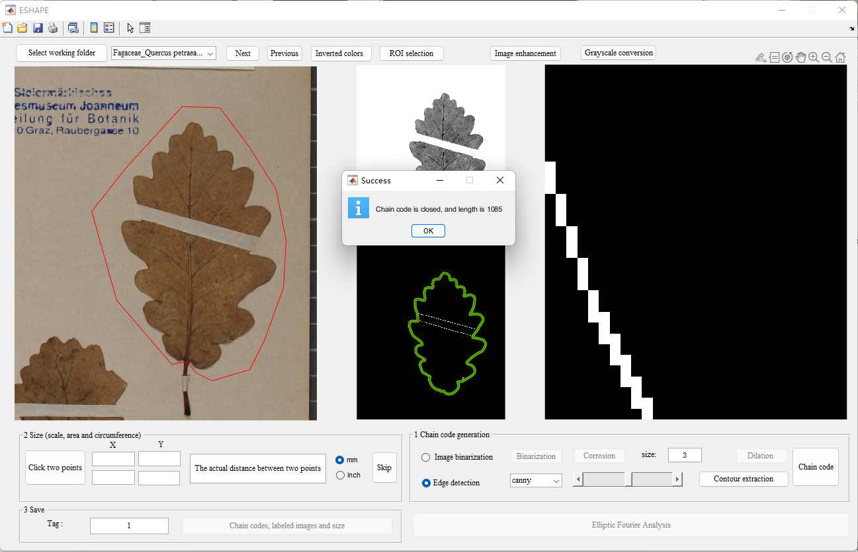

Figure

**Step 6: Size and save**

If a ruler is present, you can zoom in on the image in the left window to the location of the ruler. Then, click the 'Click Two Points' button and select a starting point and an endpoint by left-clicking with the mouse. After selection, the coordinates of the two points will be displayed in the 'X' and 'Y' text boxes. Simultaneously, enter the actual distance between the two selected points in millimeters in the right text box; for example, input '10' (Fig. 16). And select the measurement units, ‘mm’ or ‘inch’. If a ruler is absent, you can click ‘Skip’ button.

Provide a label for the object, and then click the 'Chain code, Labeled images, and size' button to save the outputs with names appended with the user-defined tag. These outputs include:

Boundary coordinates: input file name_user-defined tag_b.txt

Chain code: input file name_user-defined tag_c.txt

Size: input file name_user-defined tag_info.xlsx, Sheet 1

Labeled images: input file name_user-defined tag.png

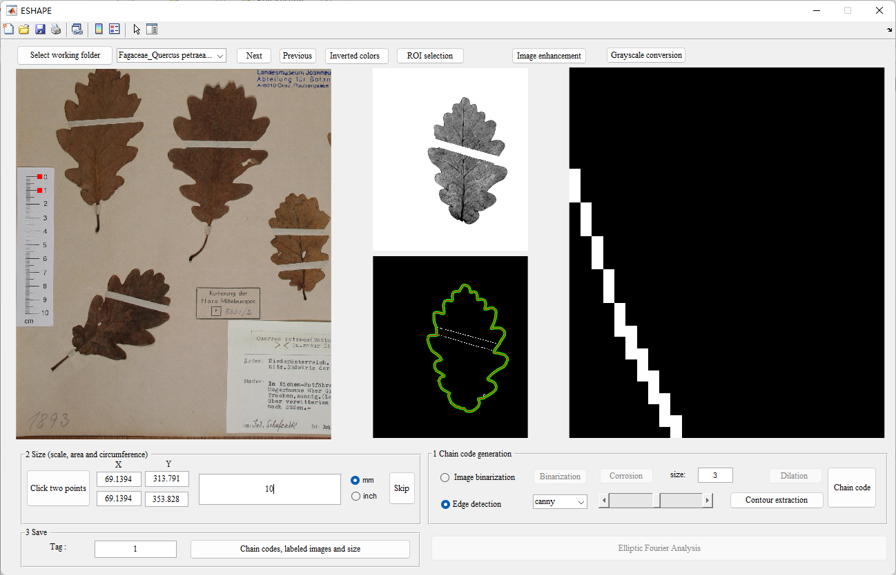

Figure

## Ellipse Fourier Analysis page

When the 'Elliptic Fourier Analysis' button is available, click it to navigate to a new page for obtaining normalized EFD data and visualizing reconstructed shapes (Fig. 17).

Click the 'Calculate and Save' button to save the EFD data. Users can input any integer as the number of harmonic coefficients; the default value is 35 (Fig. 18).

To set the visualization number of the EFD (which should be less than or equal to the maximum), click the 'Plot Curve' button, and the result is displayed in Fig. 19. Click the 'Save Curve' button, and users can choose their own path to save the curve (Fig. 20).

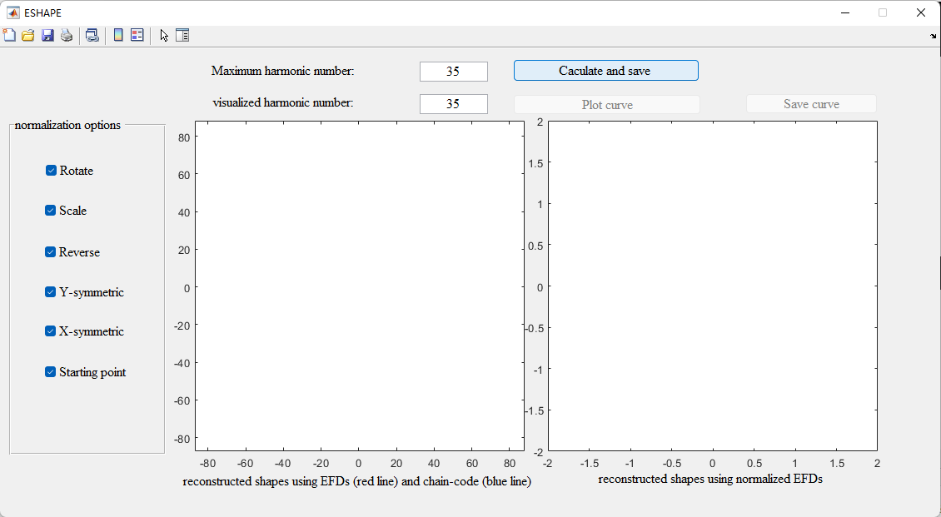

Figure 17

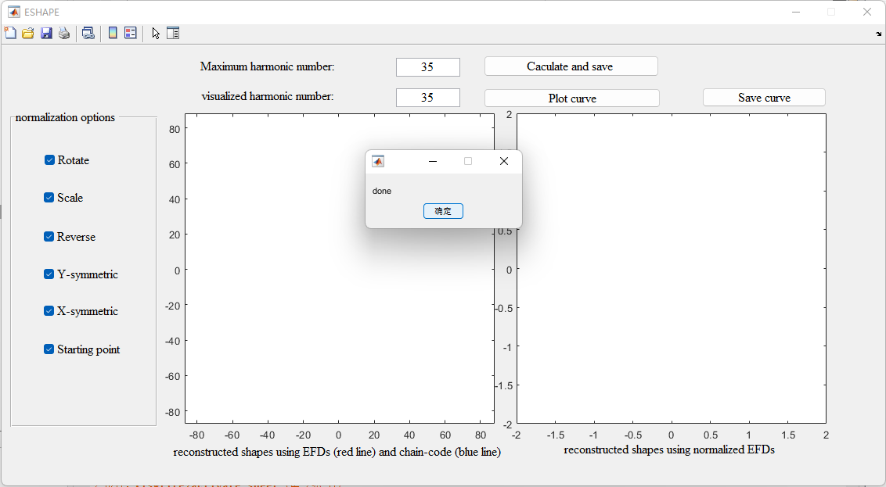

Figure 18

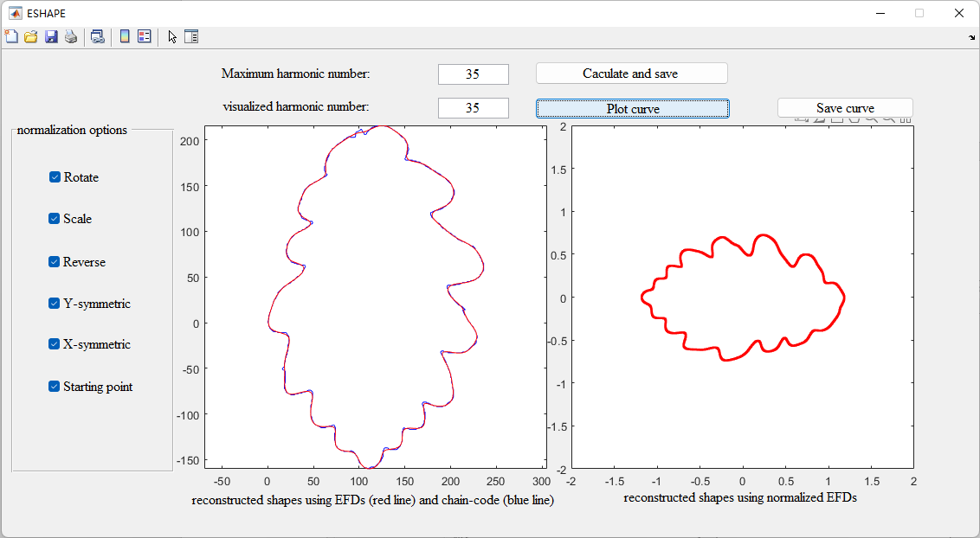

Figure 19

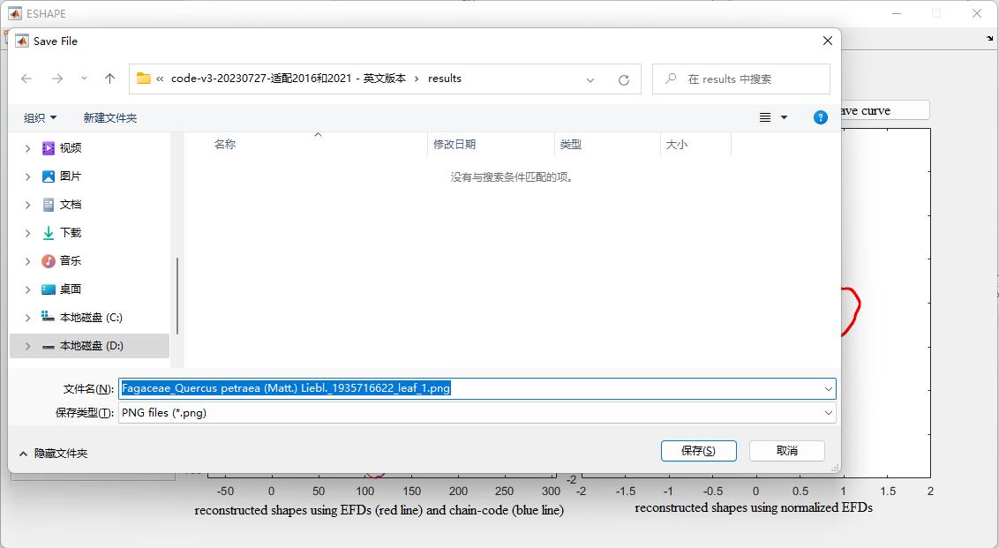

Figure 20